Name:V.Siri Chandana
ROLL NO:2520030609
Section:2
DBSE Week 6 & 7

Created a new application called Productsapi in spring tool and also added the required dependencies
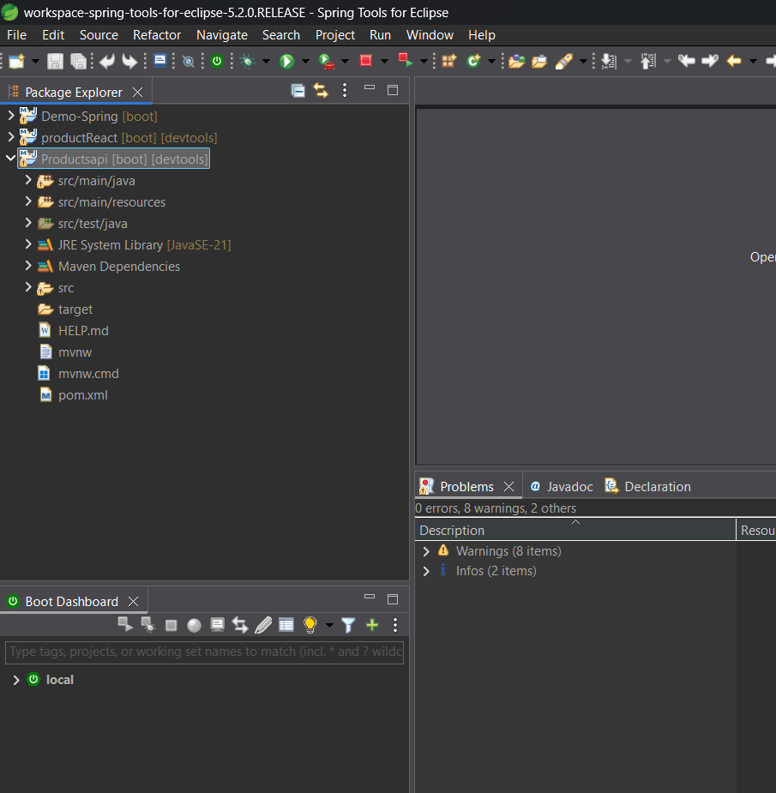

Then created a set of packages as shown in the below pic
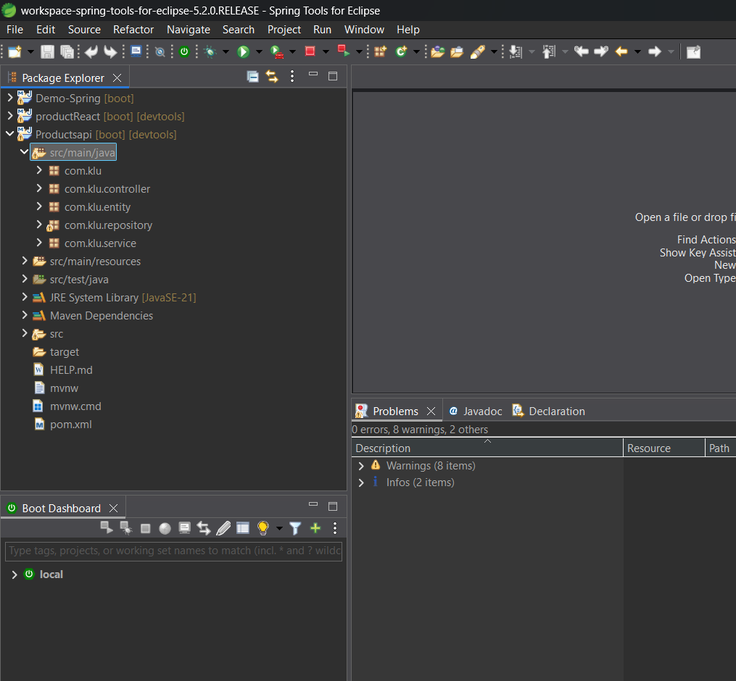

Then insides these packages created some class as shown below
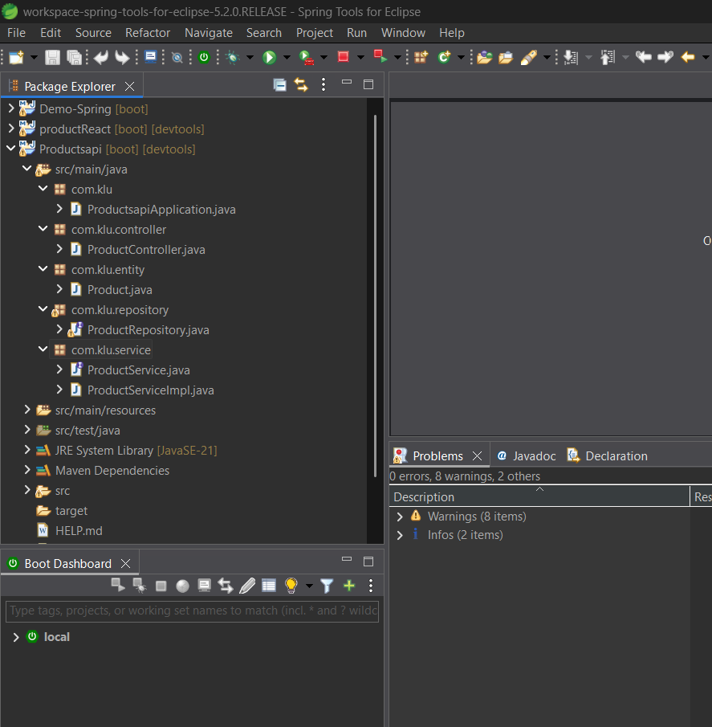
Created the classes and also added the respective codes in them
Then install the postman
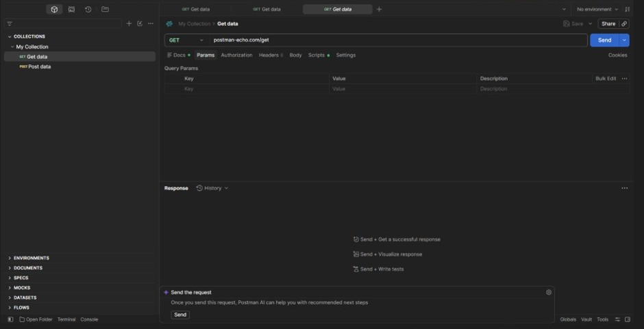
Then we have done these things
Change HTTP Method and URL:Postman Setup.
- Change the dropdown next to the URL bar from GET to POST.
- Enter the endpoint URL: http://localhost:8989/api/products

In Json payload added the below script
{
"name": "Laptop",
"description": "Dell XPS 13",
"price": 1200.0,
"quantity": 10
}
Then click the send button
But before doing the postman process First Create a database called kluh in mysql and connect it then after clicking send button in postman
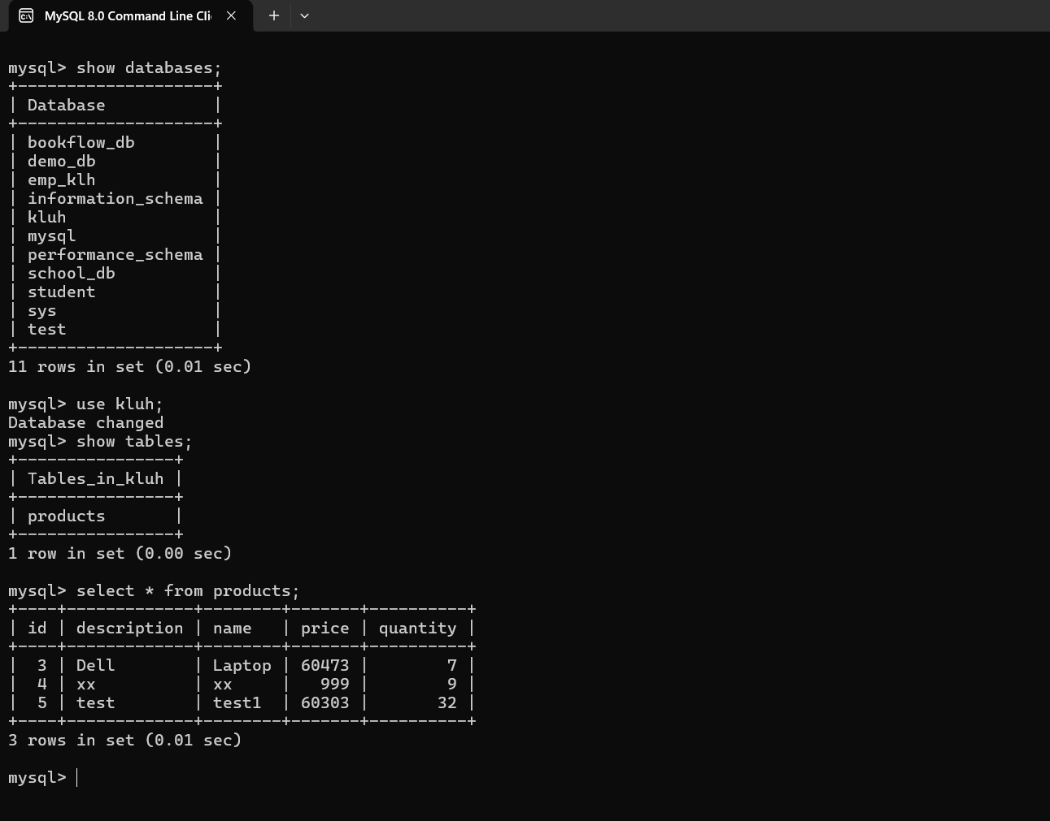
it finally added into the database

